**Medical Center Automation System**

**By**

**Priyabrota Sen**

Roll:1207024

**Tanmoy Ghosh**

Roll:1207028



**Department of Computer Science and Engineering**

**Khulna University of Engineering & Technology**

**Khulna 9203,Bangladesh**

**16 October,2014**

**Medical Center Automation System**

**By**

**Priyabrota Sen**

Roll:1207024

**Tanmoy Ghosh**

Roll:1207028

**Supervisor:**

**AL-Mahmud**

**Assistant Professor**

**Department of Computer Science and Engineering**

**Khulna University of Engineering & Technology**

**Department of Computer Science and Engineering**

**Khulna University of Engineering & Technology**

**Khulna 9203,Bangladesh**

**16 October,2014**

**Acknowledgment**

All precises goes to Almighty God for his kindness and blessing .Without his desire we would not be here as we are today.

Thanks to our project supervisor **AL-Mahmud,Assistant Professor,** **Department of Computer Science and Engineering**, **KUET** for his untiring effort as well as strong support.He truly helped through the entire project with his correct decision and necessary advice we are able to complete this software development project.

We also acknowledgment to our respected seniors for their help to accomplish this project.

Any suggestion,comment from teachers as well as seniors will be highly appreciated.

**INDEX**

**Chapter – 1**

**Introduction to JAVA…………………………………….. 1**

**Chapter -2**

**Project Overview………………………………………….. 4**

**Chapter – 3**

**Conclusion…………………………………………………. 14**

1

**CHAPTER – 1**

**INTRODUCTION TO JAVA**

1. **Objectives:**

The objective of this particular course is to make us known with the process of developing software, to adapt with the systematic way of development. Basically, we were to use our previous programming knowledge specially, object oriented programming to develop the chosen software. We were encouraged to develop the software in JAVA, which is an object oriented programming language. We know JAVA being a programming language with rich library. Its features help us a great deal to accomplish our project in the systematic way within a short period of time although the whole software was a bit complex and stretched itself. In such a short period of time, it was impossible to cover all the features of JAVA. So, necessary topics related to the software were given priority as the course required.

1. **Introduction to JAVA:**

James Gosling, Mike Sheridan, and Patrick Naughton initiated the Java language project in June 1991. Java was originally designed for interactive television, but it was too advanced for the digital cable television industry at the time The language was initially called *Oak* after an oak tree that stood outside Gosling's office; it went by the name *Green* later, and was later renamed *Java*, from Java coffee, said to be consumed in large quantities by the language's creators Gosling aimed to implement a virtual machine and a language that had a familiar C/C++ style of notation.

Sun Microsystems released the first public implementation as Java 1.0 in 1995. It promised "**Write Once, Run Anywhere**" (WORA), providing no-cost run-times on popular platforms. Java quickly became popular. With the advent of *Java 2* (released initially as J2SE 1.2 in December 1998 – 1999), new versions had multiple configurations built for different types of platforms.

Java, a pure object oriented programming language, is now-a-days a well spread & widely used by the community of world programmers. Basically, it is related to C++ which is the direct descendent programming language C. Much of the characteristics of Java were inherited from these two languages. So, it is obvious those, many of its defining characteristics comes from or are responses to its predecessors. Differences are also there.

2

Java is purely object oriented while we can treat C++ as a hybrid one. Java overcame many of the disadvantages which were faces previously. As being object-oriented it possesses and strictly maintains the characteristics-

1. ***Class and Object***
2. ***Inheritance***
3. ***Data Encapsulation***
4. ***Polymorphism***

**3.Advantages of Java:**

**1. Java is easy to learn**Java was designed to be easy to use and is therefore much easier to write, compile, debug, run and learn than other programming languages.

**2. Java is object-oriented**  
This allows you to create modular maintainable applications and reusable code.

**3.Java is platform-independent**  
One of the most significant advantages of Java is its ability to move easily from one system to another. The ability to run the same code on many different systems is crucial to www, and Java succeeds at this by being platform-independent at the source and almost binary levels.

**4. Java is distributed**  
Java is designed to make distributed computing easy with the networking capability that is inherently integrated into it. Writing network programs in Java is like sending and receiving data to and from a file.

**5. Java is secure**Java considers security as part of its design. The Java language, compiler, interpreter, and runtime environment were each developed with security in mind.

**6. Java is robust**Robust means reliability. Java puts a lot of emphasis on early checking for possible errors, as Java compilers are able to detect many problems that would first show up during execution time in other languages.

**7. Java is multithreaded**  
Multithreaded is the capability for a program to perform several tasks simultaneously within a program. In Java, multithreaded programming has been smoothly integrated into it, while in other languages, operating system-specific procedures have to be called in order to enable multithreading.

3

**8. Graphical User Interface**

When a programming language introduces Graphical User Interfaces(GUI) directly as a part of it, like JAVA, it enhances the productivity of the developer making things very easy and simple. Graphical User Interface

4

**CHAPTER – 2**

**PROJECT OVERVIEW**

**1. Project (Medical Center Automation System):**

Brief Overview of Medical Center Automation System

To develop a Medical Center Management system, we take care of patient registration, drug information and concerns such as drug enquiries and complaints.

The current manual system is slow laborious and error prone to computerize the same for quicker efficient results and customer satisfaction

The system is useful in various ways as the information about the patients who are taking the free services from the health center all the details are already stored in the database , so the service is done in no time . All the information about the drugs are also maintained in the database.

1. **Pre-Requisition for this Project:**

To run the Project successfully we needed the help of some prerequisite elements like

1. MySQL Database Management System
2. Jdk1.8.0_05

The computer in which the software will be installed has to have a Database Management System and it has to be MySQL, the open source database management system.

5

1. **Use Case diagram:**

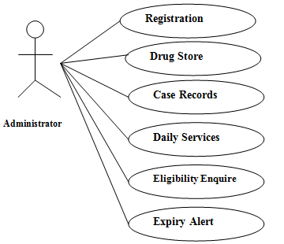

1. **System analysis of Medical Center Automation System:**

Analysis is the detailed study of the various operations performed by a system and their relationships within and outside of the system. A key question is: What must be done to solve the problem? One aspect of analysis is defining the boundaries of the system and determining whether or not candidate system should consider other related systems. During analysis, data are collected on the available files, decision points, and transactions handled by the present system.

6

**Module Description**

This section attempts to describe each module of the project in brief, and the detailed description of each of these modules is spread throughout this document.

The Health Center Management System project has been divided into four modules. They are

1. Registration
2. Drug Stores
3. Case Records
4. Daily Entries

**Registration**

This module has been divided into two sub modules. They are

* 1. **1**. Inserting the new records
  2. **2**. Retrieving the record

1. **Inserting the new records**

The information of the students and employees are send from the different departments to provide the free service. All the records which are send from the departments are entered into the database and each member is represented through the unique number known as the opno. Inserting of the new records include the opno i.e which is allotted uniquely for providing the free services, Name, Age, Sex, Address , Family members of the employee and other Beneficiaries under the S.V. Health Center.

7

**2. Retrieving the details**

The records which are entered into the database are retrieved to check whether that person who has come to take the service at the health center is eligible to take the service are not. This is done by entering the opno that has allotted to the patient.

**Drug Stores**

This module is divided into three modules. They are

**1**. Drug Entry

**2**.Updating Drug Entry

**3.**Stock Details

**1. Drug Entry**

This is an entry done by entry operator after getting the stock from the medical transcripters and the information is stored in the database. The information is in the form starting with the Drug name, in-stock, Expiry date1 and Expiry date2. The Drug name is uniquely identified such that the database is maintained without any complexity. Here the expiry date is represented in the form of month-year, but not in the form mm / dd / yy. The stock is first stored in the main drug stores and every week it is shifted to the pharmacy store by watching the stock at the pharmacy house.

1. **Updating Drug Entry**

This is an entry done by same entry operator after the drugs all entered in the database. The drugs should be shifted to the pharmacy house by checking the stock at the pharmacy house. First the Main drug store maintains the stock and the drugs are shifted to the pharmacy house periodically. This periodical shifting of the drugs are updated such that the drug house knows how much of the stock is present in the drug store, Here the drug stores mainly considers the expiry date as the main criteria the drugs which have the nearer expiry date are shifted to the pharmacy house.

8

1. **Stock Details**

The stock details are so important such that we know how many drugs are in the main store, what are the expiry dates of the drugs.When the stock is taken it will minimum of two and maximum of five expiry dates. So it is better to watch the expiry dates so that the drugs are shifted to the pharmacy house according to the drugs which are having the early expiry date.

**Case Records**

This module has been divided into three sub modules. They are

**1**.Students In-Patients Records

**2**. Employees In-Patients Records.

**3**.Out – Patients Records

**1. Students In-Patients Records**

The information about the in-patients should be notified such that the treatment for the patient is done in the proper way. The students who are in-patients are maintained separately because everything to the student is served freely i.e there is no bed charges, no charge for the scanning, no charge for the X-Rays and every thing is supplied freely. There may be special cases that areused for case studies how that disease has occurred and what are the precautions are to be taken to overcome that disease. The diseases that affect the other patients are shifted to the Isolation ward such that disease is not affected to the other patients.

**2. Employees & Beneficiaries In-patient Records**

The employees and other beneficiaries are maintained separately.

The employees who are working in the university are included in this section. Employees such that teachers, staffs and other employees. Medicine and other services are freely served to them.

**9**

**3. Out-Patients Record**

The patients who are not the members in the university are separated in this section. They are served for the common problems which are not serious.

And for this patient medicines are not freely supplied.

**Services:**

Daily records are then divided into two sub modules. They are

**1**.Drug Services

**2**.Test Services

**1. Drug Services**

The patients who are registered as student and employees in the university will get the medicine freely. They are not charged for the services. Out patients will no tget the services.

**2. Test Services**

The patients who are registered as student and employees in the university will get the medicine freely. They are not charged for the services. Out patients will get the services but the must pay for the services.

1. **Table of Database:**

These are the tables which are used in the database section of the project

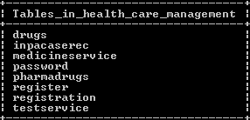

10

**Drugs Table:**

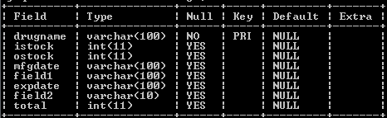

**Case Records Table:**

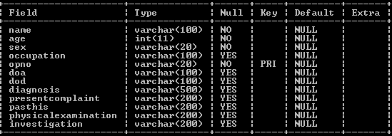

**Registration Table:**

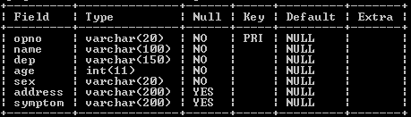

11

1. **Screens:**

**Start Page :**

Administrotor can enter the whole system by login in the home page

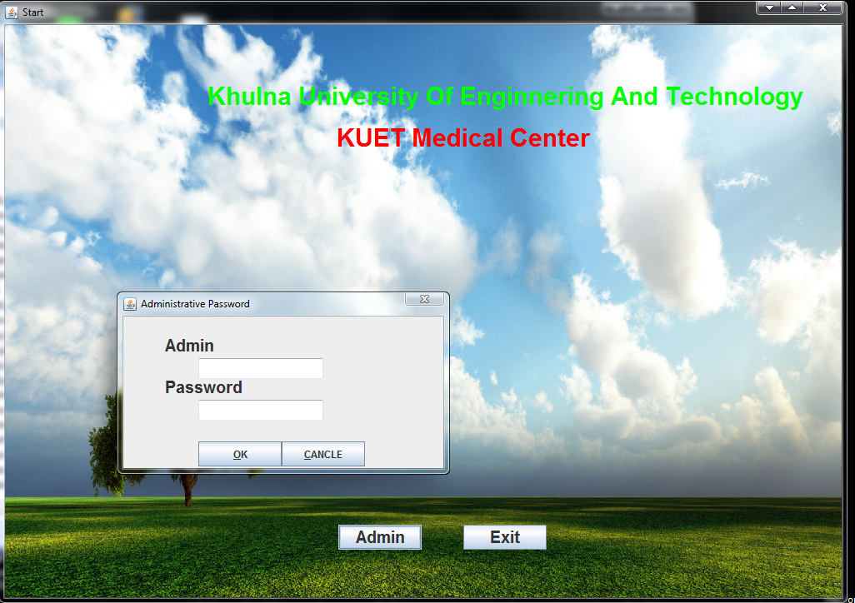

**Home Page :**

Administrator can access these option

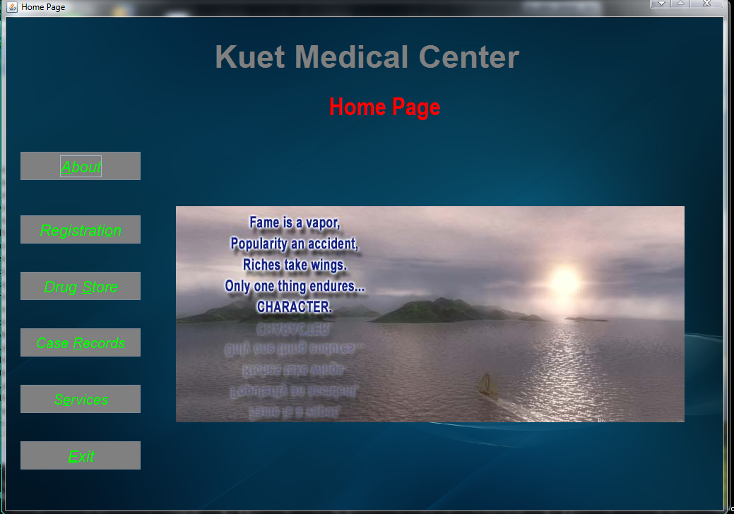

12

**Registration form :**

Student and employee can register through this form. Id number must be different for every person. Two person can not have same id number.

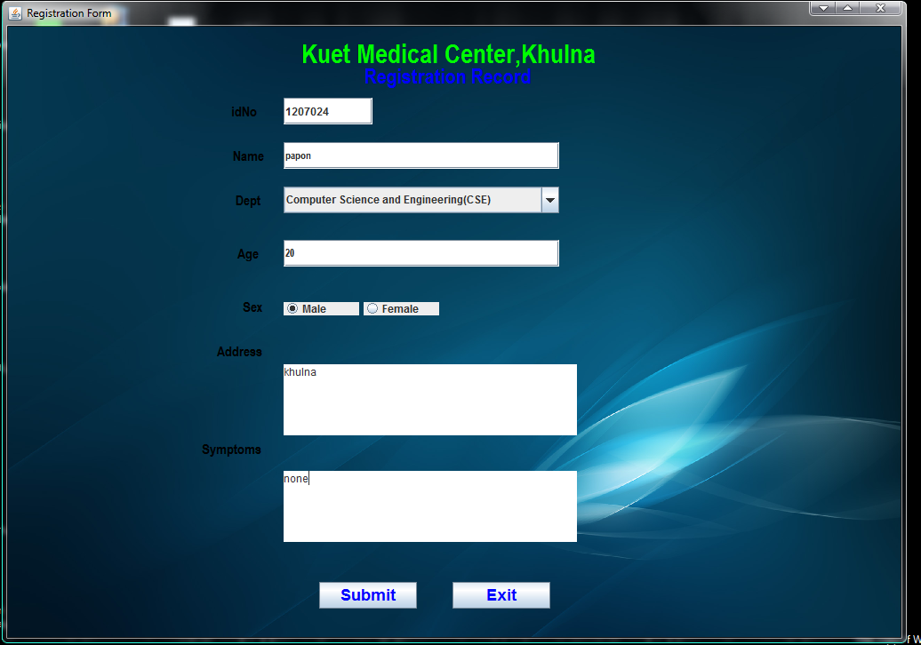

**Drug Insert:**

Administrator can insert drug . Here drug name, drug amount, expire date and manufacture date must be entered.

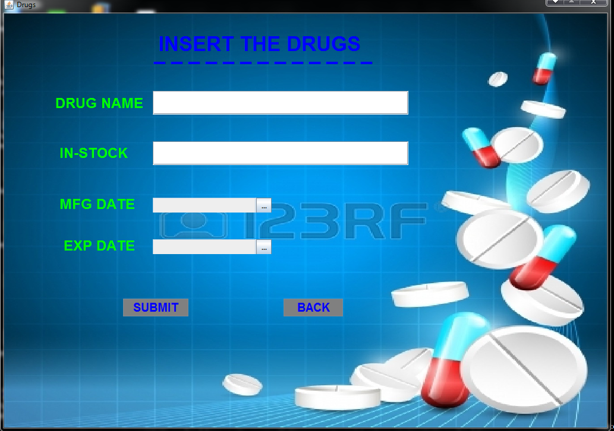

13

**Update drugs:**

Administrator can get the details of any drug and can update the drug. He can delete or insert new amount of the drug. Manufacture date and expire date of the new drug must be entered.

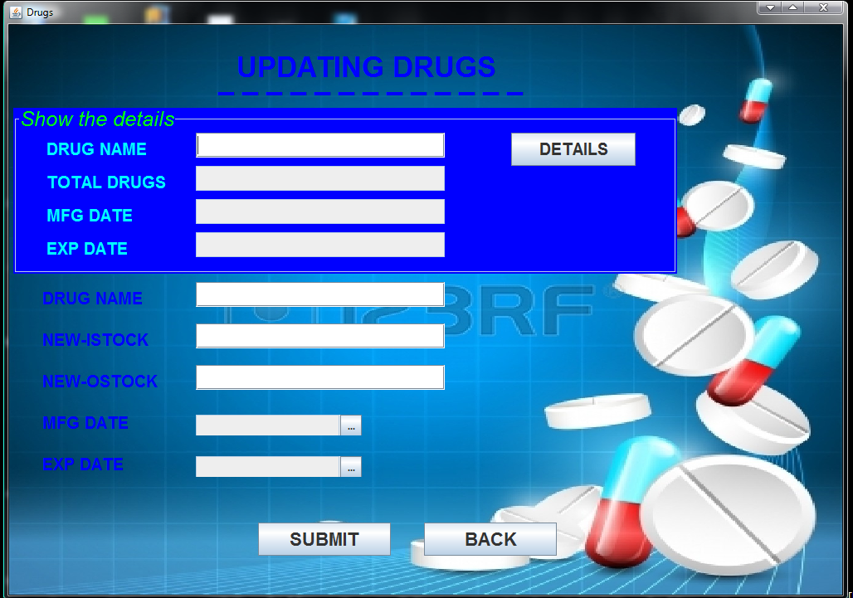

**Serious case:**

In serious case patent can be admitted in the medical center. Then he must fill the an another form which store the record of admitted patient.

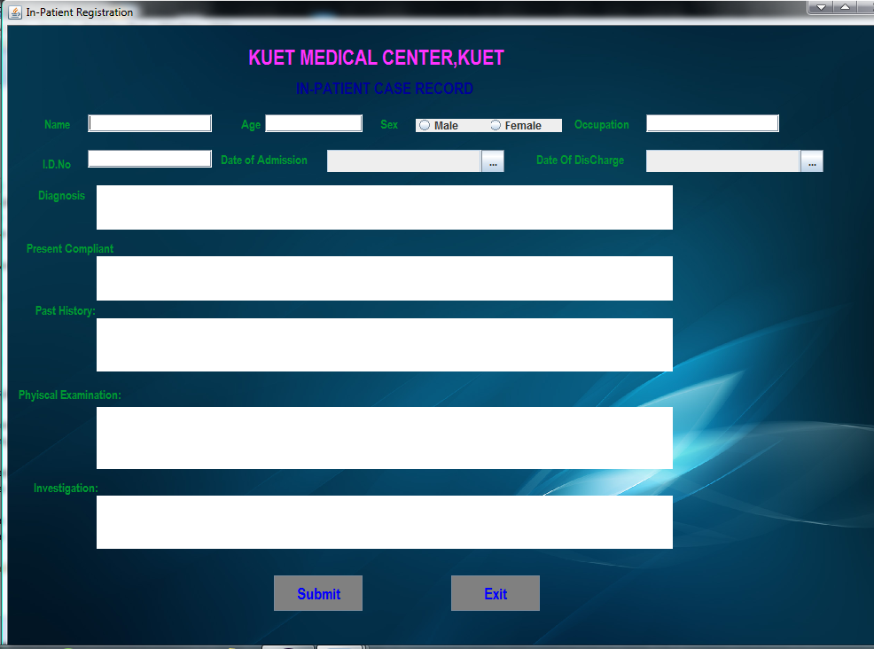

14

**CHAPTER – 3**

**CONCLUSION**

**Advantages and Disadvantages:**

Advantages

1. A fast and more efficient service to all patients. As there are thousands of patients records; Searching process is an easy task.

2. Saving in staff time in entering and manipulating data.

3. Easy input, deletion and manipulation of lot, patients details.

4. Simple correction of input errors and we can asses the calculations accurately

## Disadvantage

1. Loss of data when electronic fluctuations occur.
2. Some times operator can make mistake when he enter data.

**Future Plan:**

1. Add doctor account and patient account.
2. Make direct relation between doctor and patient through online.
3. Use networking in the project.

15

**Discussion:**

At First it was difficult for us to comprehend the concept of the language but with the help and proper guidance of our supervisor AL-Mahmud sir we were able to complete our project in time .As a beginner and as our first software development project “Medical Center Automation System” may lack in some points but we tried heart and soul to give it a wonderful state and make is useful.

**References:**

**1. JAVA HOW TO PROGRAM**

**-By P. J. Deitel & H. M. Deitel**

**2. The Complete reference Java (J2SE 5th Edition)  
 - By Herbert Schildt**

### 3. [MySQL Tutorial - Tutorialspoint](http://www.google.com.bd/url?sa=t&rct=j&q=&esrc=s&source=web&cd=1&cad=rja&uact=8&ved=0CCAQFjAA&url=http%3A%2F%2Fwww.tutorialspoint.com%2Fmysql%2F&ei=Dgk-VPf7CI-2uAS2vIGYDw&usg=AFQjCNFgU5vRCSRmUN5BoF_zcMe2YOfMng)

www.tutorialspoint.com/mysql/

### 4.[Java Tutorial - Tutorialspoint](http://www.tutorialspoint.com/java/)

www.tutorialspoint.com/java/